

3 6 3



3 3 3 3



5 7



3 6 3



4 4 4

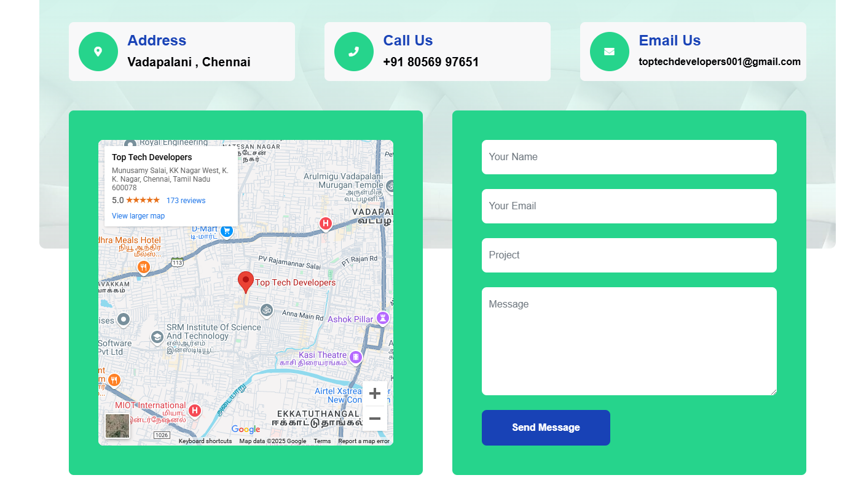

1 5 5 1





2 6 4

Container



Container fluid

2 2 2 2 2 2



4 4 4

container